1.Design and deploy a scalable network architecture using AWS Transit Gateway to simplify network connectivity between multiple VPCs:
first need to create 3 VPC and 1subnets accordingly.
Then need to add route tables for each subnet and internet gateway for the subnets.
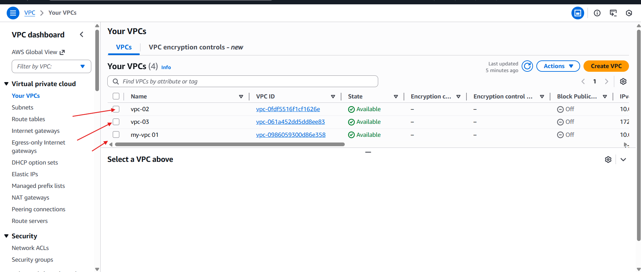
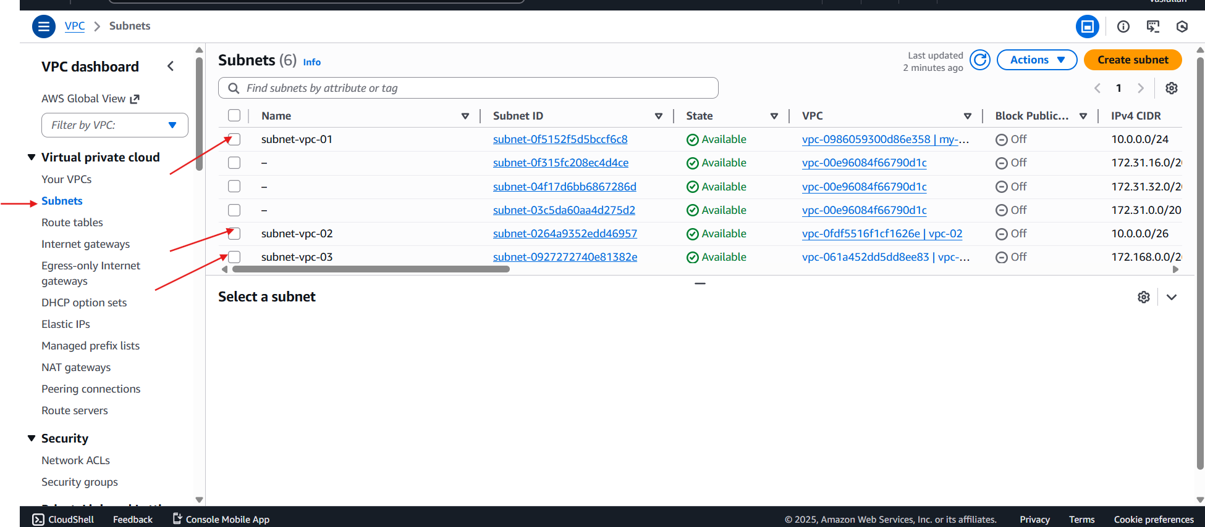
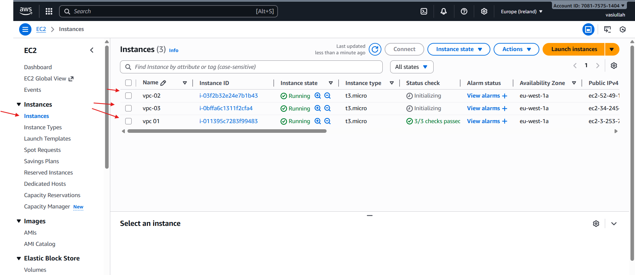

And add internet gateway in route tables and save it.
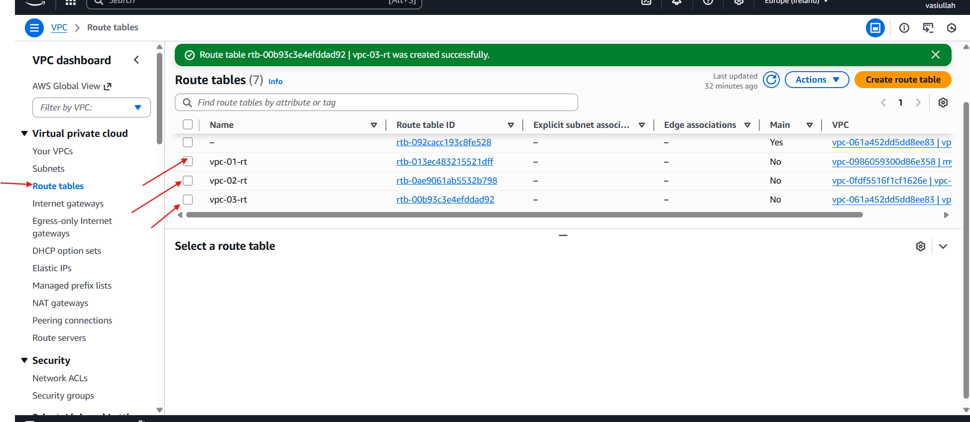
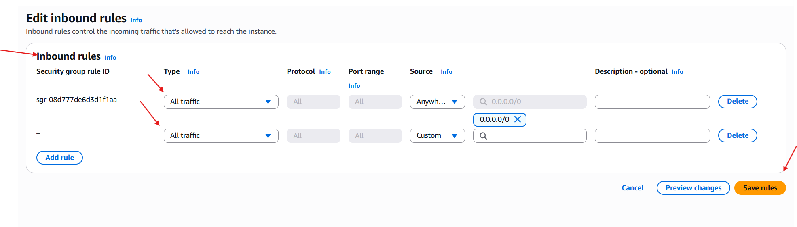

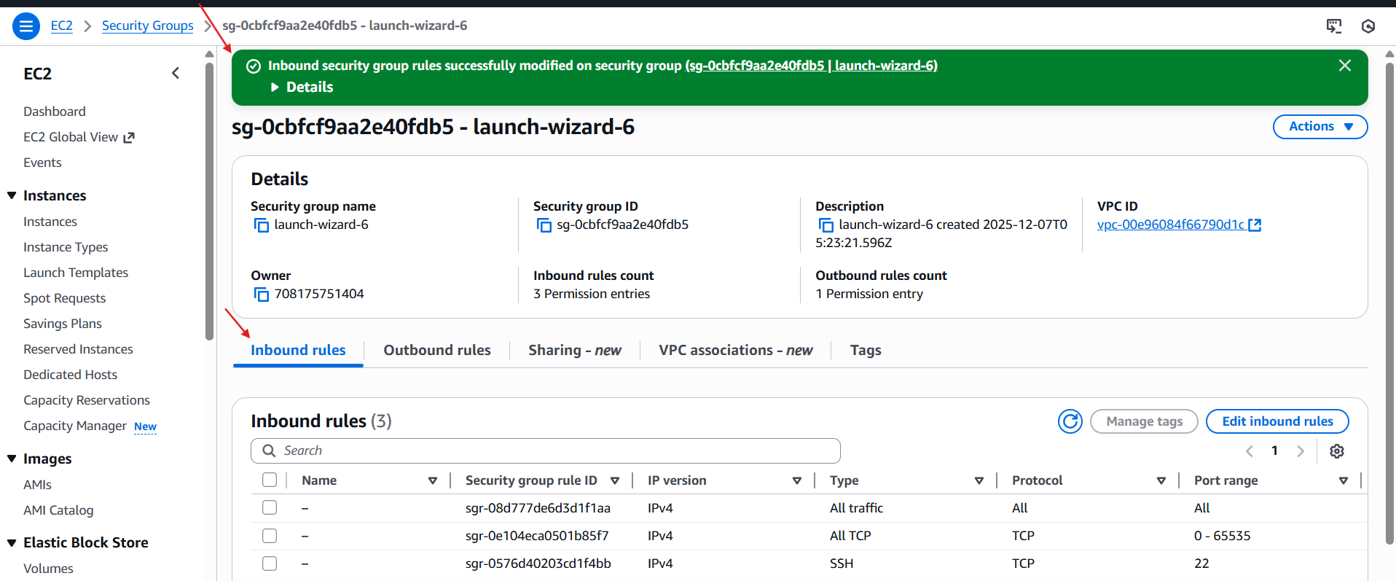

Now need to connect transit gateway and need to attach 3 VPC in attachment.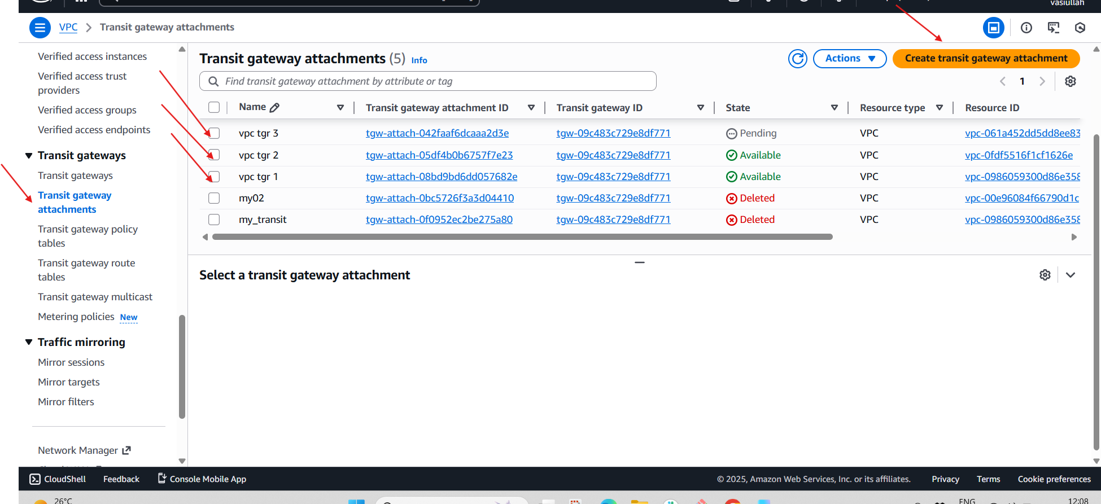
Now need to entre in the VPC route tables and save it.
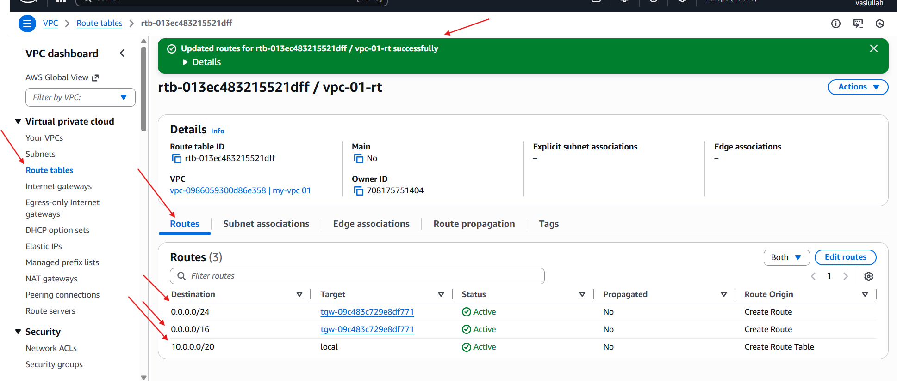
Once it got saved now launch the instance and check with their public and private IP.
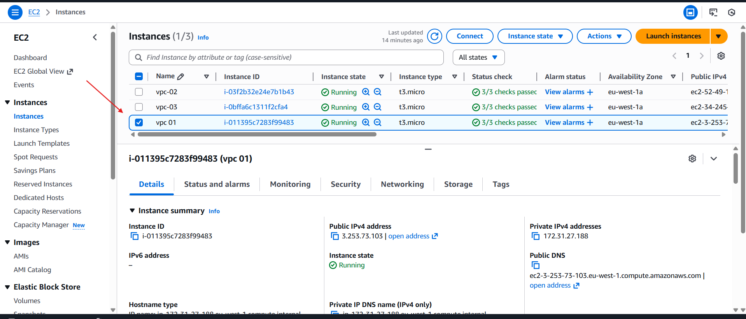
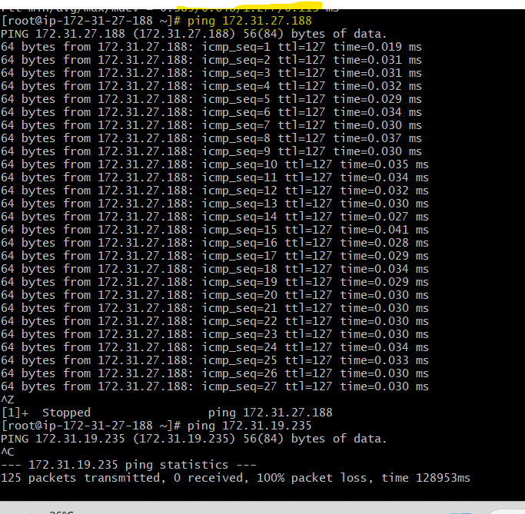

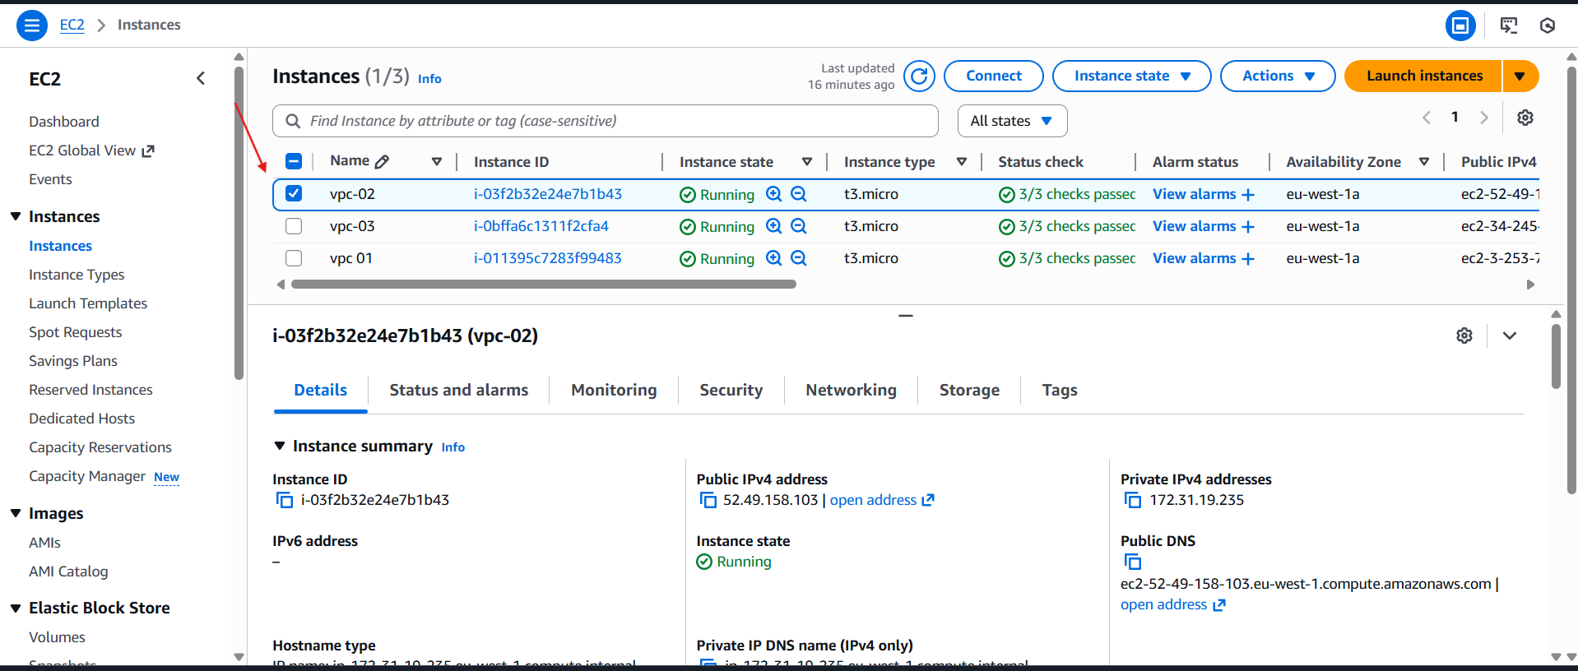
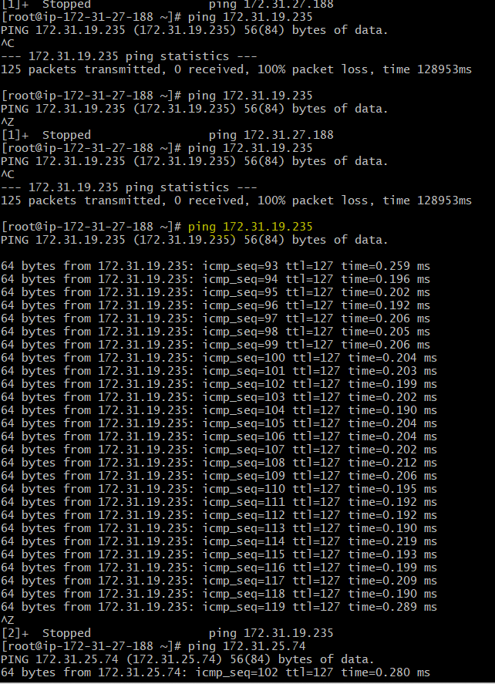

Once it got saved now launch the instance and check with their public and private IP.
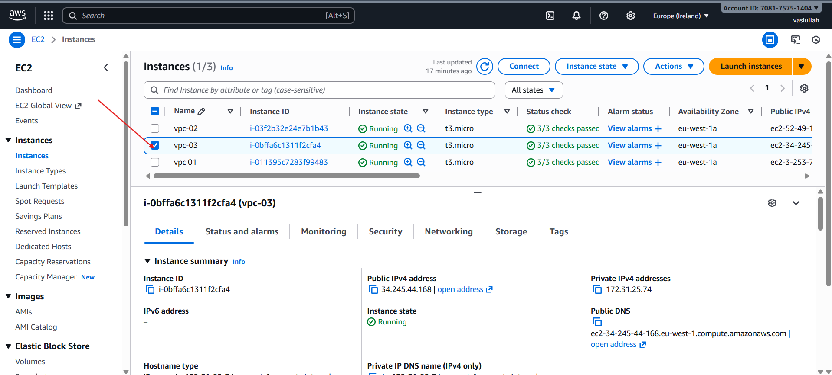
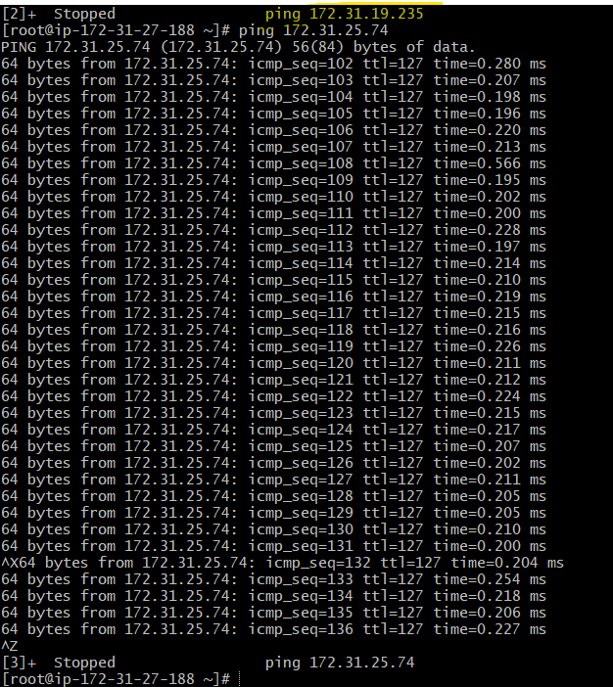

2.Configure VPC endpoints to securely access AWS services without internet gateways or NAT gateways, ensuring data privacy and minimizing exposure to external threats:
Go to Aws console.
Go to VPC-->create VPC.

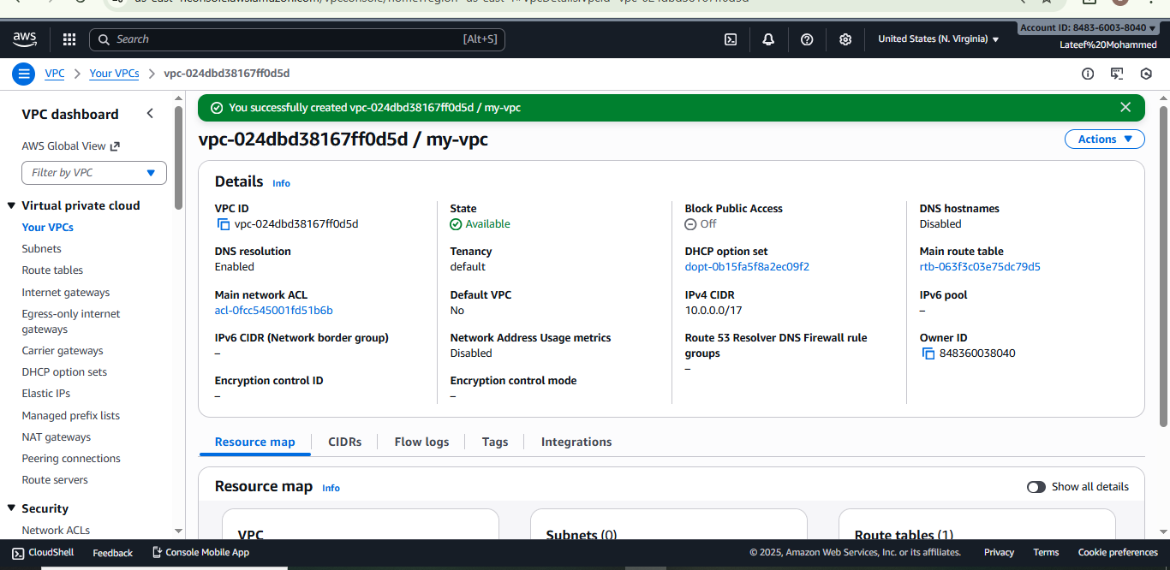

create internet gateway-->attach to created VPC.
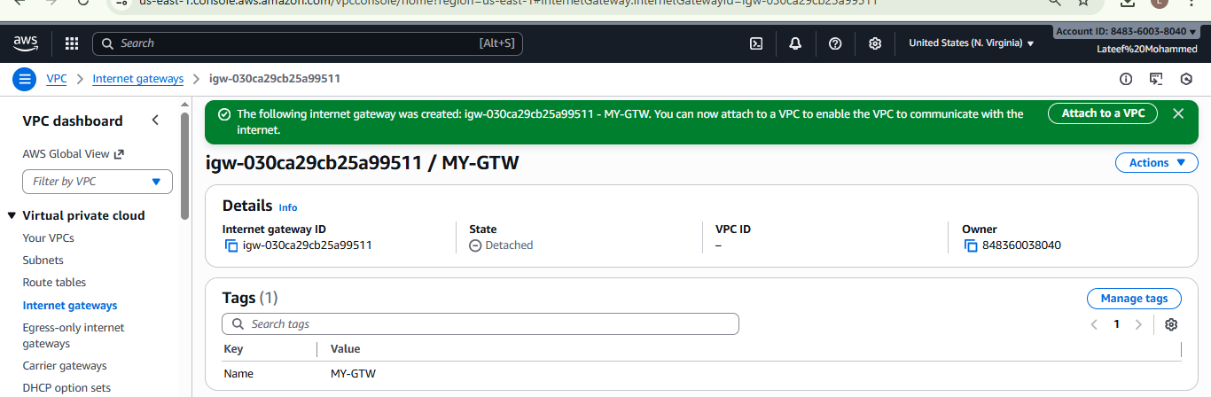
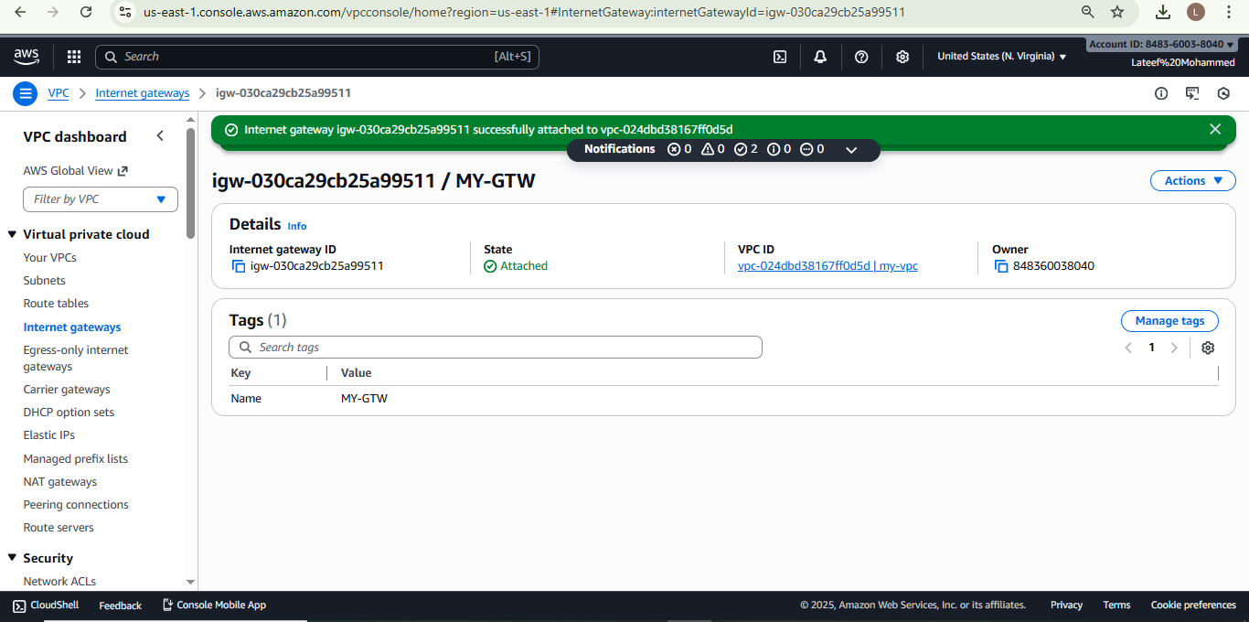
create 2 subnets public and private.
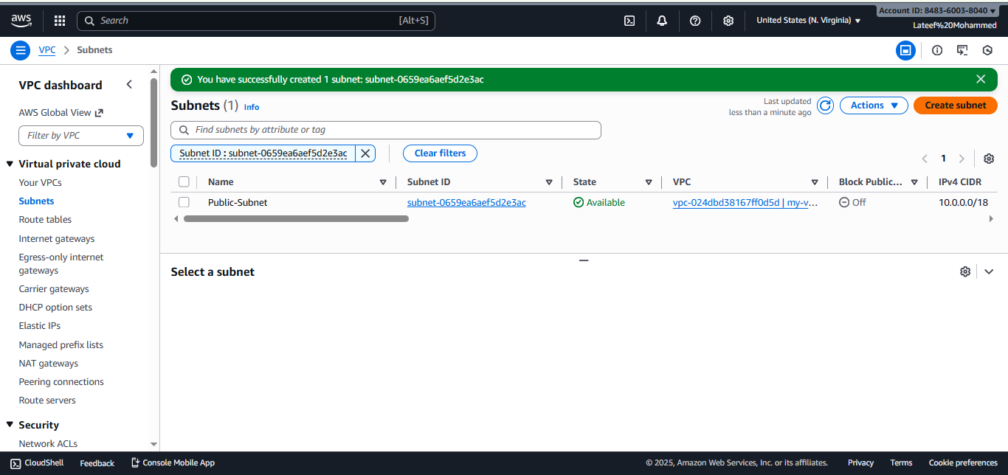

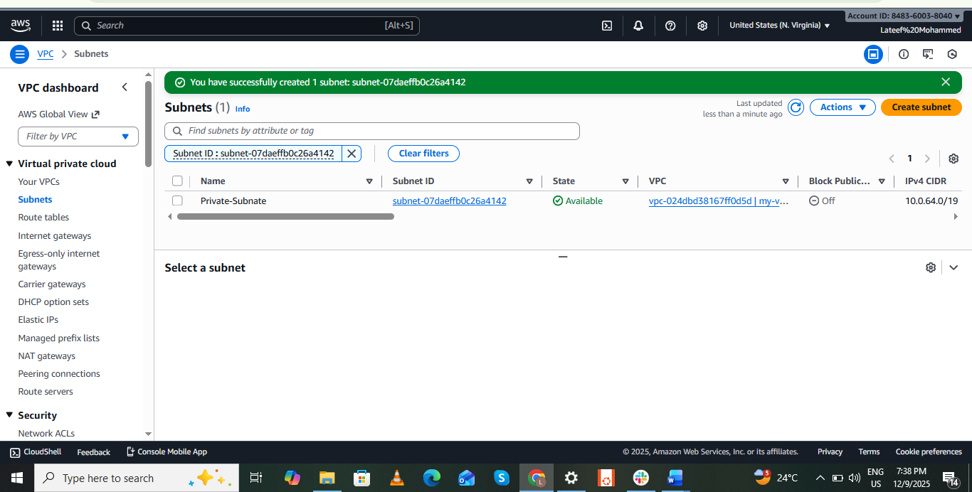

create 2 route tables public and private.

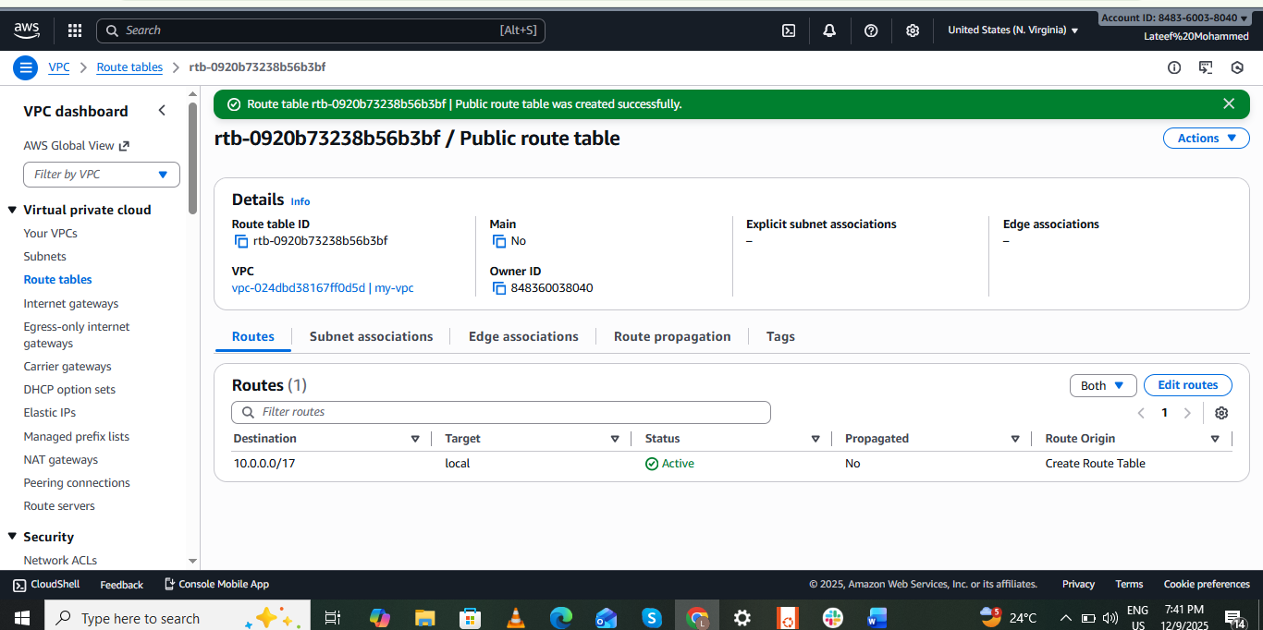

edit route table for public-->add route 0.0.0.0/0 target internet gateway.
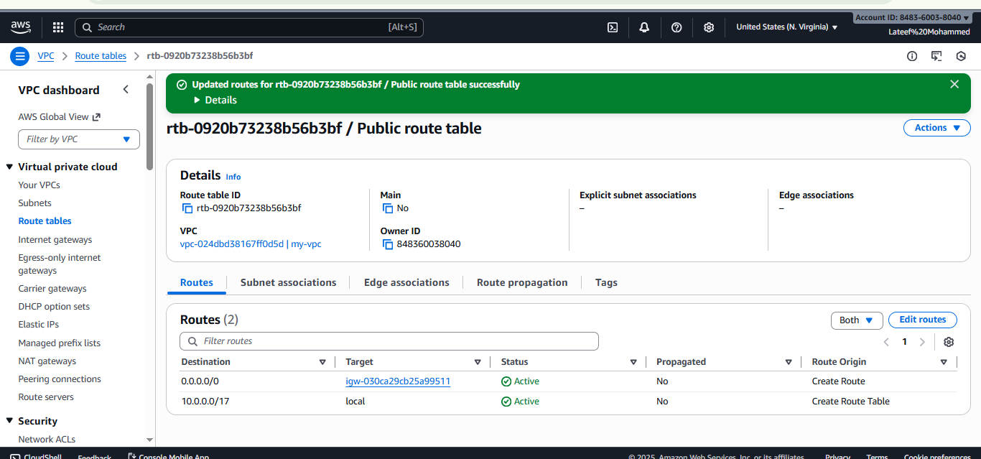

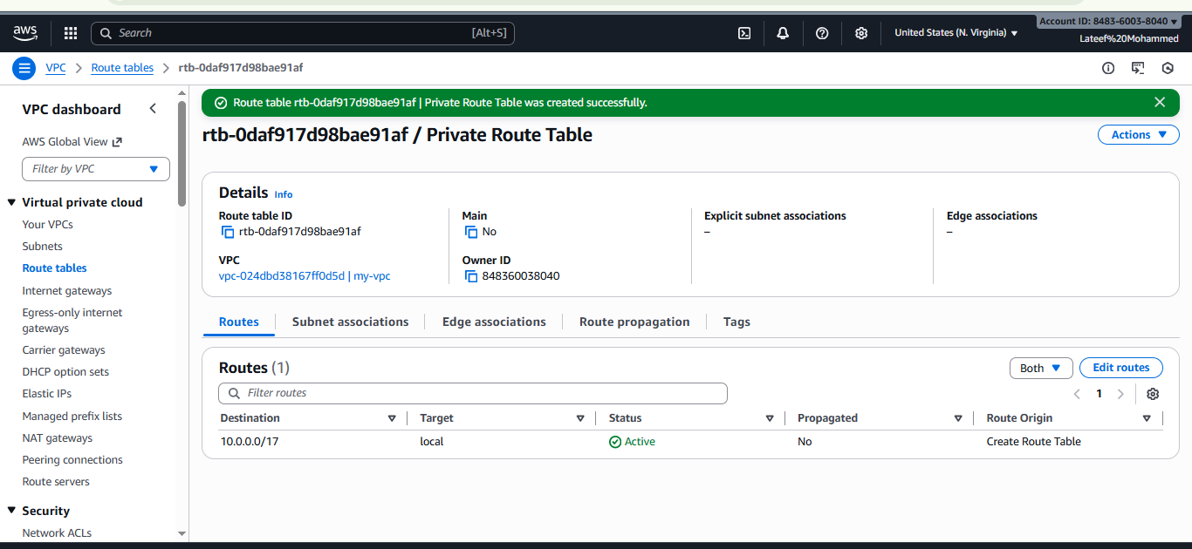

By using a command, ssh -i pem.key ec2-user@publicIp.
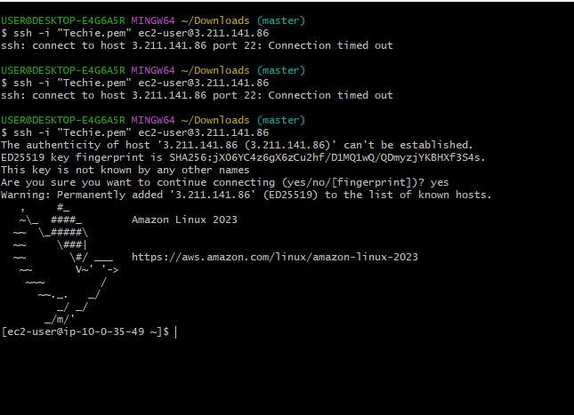

By using a command, ssh -i pem.key ec2-user@private.

